Aim: To compute and plot the intensity histograms of digital images, implement Global Histogram Equalization to enhance image contrast, and perform Histogram Matching (Specification) using cumulative distribution function (CDF) mapping to align the tonal distribution of a source image with a specified reference image.
Program:
import cv2
import numpy as np
import matplotlib.pyplot as plt
import sys

image_path = r"C:\Users\Dev Radia\Desktop\image2.jpg"
source_path = r"C:\Users\Dev Radia\Desktop\image2.jpg"
reference_path = r"C:\Users\Dev Radia\Desktop\image3.jpg"

image = cv2.imread(image_path, cv2.IMREAD_GRAYSCALE)

if image is None:
print(f"Error: Could not load image from {image_path}")
sys.exit()

histogram = cv2.calcHist([image], [0], None, [256], [0, 256])

plt.figure(figsize=(8, 5))
plt.title('Histogram of Original Image')
plt.xlabel('Pixel Value')
plt.ylabel('Frequency')
plt.plot(histogram, color='black')
plt.xlim([0, 256])
plt.grid(True, linestyle='--', alpha=0.6)
plt.show()

equalized_image = cv2.equalizeHist(image)

plt.figure(figsize=(10, 5))
plt.subplot(1, 2, 1)
plt.title('Original Image')
plt.imshow(image, cmap='gray')
plt.axis('off')

plt.subplot(1, 2, 2)
plt.title('Equalized Image')
plt.imshow(equalized_image, cmap='gray')
plt.axis('off')
plt.tight_layout()
plt.show()

equalized_hist = cv2.calcHist([equalized_image], [0], None, [256], [0, 256])

plt.figure(figsize=(8, 5))
plt.title('Histogram of Equalized Image')
plt.xlabel('Pixel Value')
plt.ylabel('Frequency')
plt.plot(equalized_hist, color='black')
plt.xlim([0, 256])
plt.grid(True, linestyle='--', alpha=0.6)
plt.show()

source_image = cv2.imread(source_path, cv2.IMREAD_GRAYSCALE)
reference_image = cv2.imread(reference_path, cv2.IMREAD_GRAYSCALE)

if source_image is None:
print(f"Error: Could not load source image from {source_path}")
sys.exit()

if reference_image is None:
print(f"Error: Could not load reference image from {reference_path}")
sys.exit()

source_hist = cv2.calcHist([source_image], [0], None, [256], [0, 256])
reference_hist = cv2.calcHist([reference_image], [0], None, [256], [0, 256])

if source_hist.sum() > 0:
source_hist /= source_hist.sum()

if reference_hist.sum() > 0:
reference_hist /= reference_hist.sum()

source_cdf = source_hist.cumsum()
reference_cdf = reference_hist.cumsum()

if not np.any(np.isnan(source_cdf)) and not np.any(np.isnan(reference_cdf)) and len(source_cdf) > 0 and len(reference_cdf) > 0:
mapping = np.interp(source_cdf, reference_cdf, range(256))
matched_image = mapping[source_image]
matched_image = matched_image.astype(np.uint8)
else:
print("Warning: CDFs contain NaN values or are empty. Skipping matching.")
matched_image = np.zeros_like(source_image, dtype=np.uint8)

plt.figure(figsize=(14, 5))

plt.subplot(1, 3, 1)
plt.title('Source Image')
plt.imshow(source_image, cmap='gray')
plt.axis('off')

plt.subplot(1, 3, 2)
plt.title('Reference Image')
plt.imshow(reference_image, cmap='gray')
plt.axis('off')

plt.subplot(1, 3, 3)
plt.title('Matched Image')
plt.imshow(matched_image, cmap='gray')
plt.axis('off')

plt.tight_layout()
plt.show()

INPUT IMAGES:
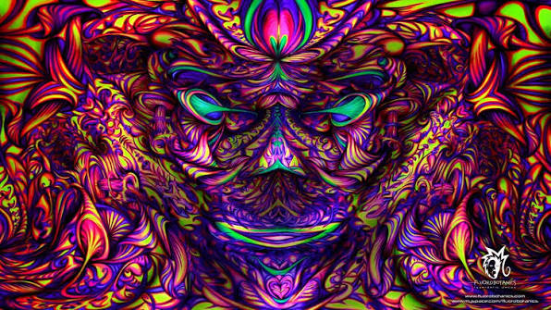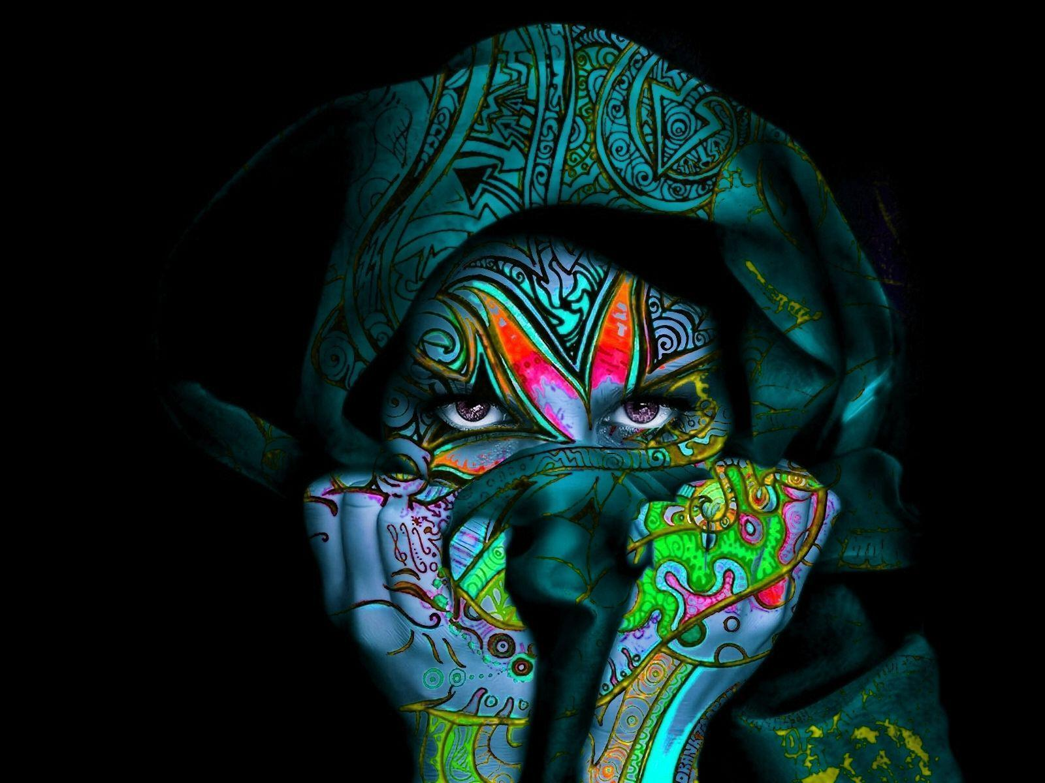

OUTPUT:
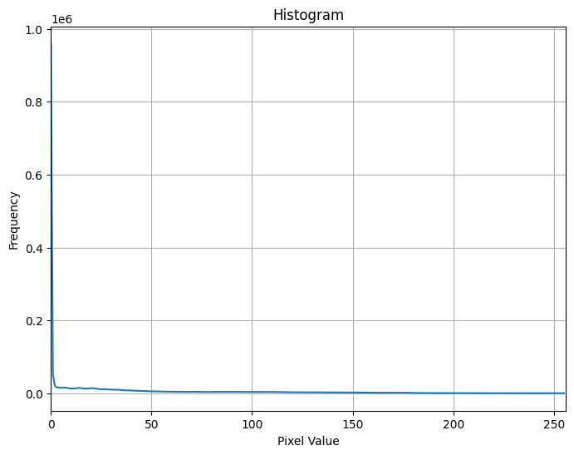
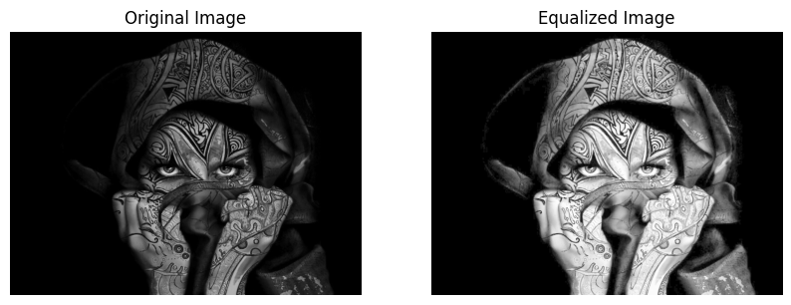
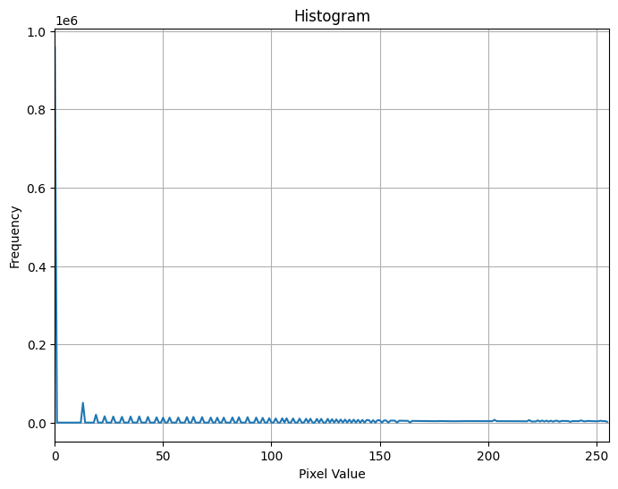
<Figure size 640x480 with 0 Axes>
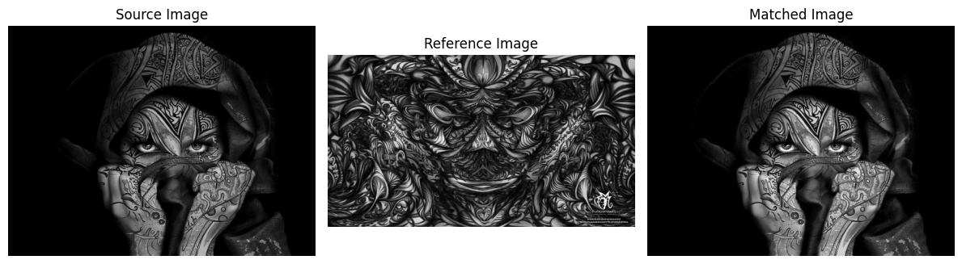

OBSERVATION:
The original grayscale image exhibits a massive, dominant peak at intensity 0 comprising nearly one million pixels due to the extensive solid-black background, leaving the remaining face and hood details distributed thinly across the lower-to-mid gray range.
Applying global histogram equalization stretches the non-zero foreground intensities outward across the full 0 to 255 spectrum, which drastically increases the brightness and contrast of the face, eyes, and intricate headscarf patterns while preserving the background black level. The resulting equalized histogram displays the characteristic discrete comb-like distribution across the dynamic range, reflecting the discrete bin-mapping of cumulative distribution function (CDF) equalization.
In the histogram matching stage, the cumulative distribution of the source image is mapped directly to the CDF of the richly textured reference image using interpolation. Because the reference image contains a well-distributed range of mid-tones and bright highlights, the matched image successfully adopts these tonal characteristics, producing richer local depth and punchier contrast on the subject's face and hood while keeping the dark background intact.
CONCLUSION:
Global Histogram Equalization and Histogram Matching (Specification) were successfully simulated and analyzed using cumulative distribution function (CDF) mapping. While global histogram equalization effectively expanded the compressed foreground intensities across the full dynamic range to enhance contrast, it created distinct intensity gaps due to discrete mapping. Histogram matching demonstrated a more controlled tonal transformation by mapping the source CDF directly to the reference image's CDF via interpolation, effectively transferring the target contrast and brightness profile while preserving the structural integrity of the foreground subject.

